 | Price | Quantity
Friday 6th July: Welcome drinks at the Halfway House | n/a
Accommodation Friday evening (single occupancy en-suite) | £34.00
Saturday 7th July: Cold continental breakfast pack | £6.00
Saturday 7th July: Campus Tour (approx. 4pm) | n/a
Saturday 7th July: Drinks Reception and Gala Dinner with disco | £40.00
B&B Saturday evening (single occupancy en-suite accommodation) | £34.00
Sunday 8th July: Cold continental breakfast pack | £6.00
Total Amount to pay:
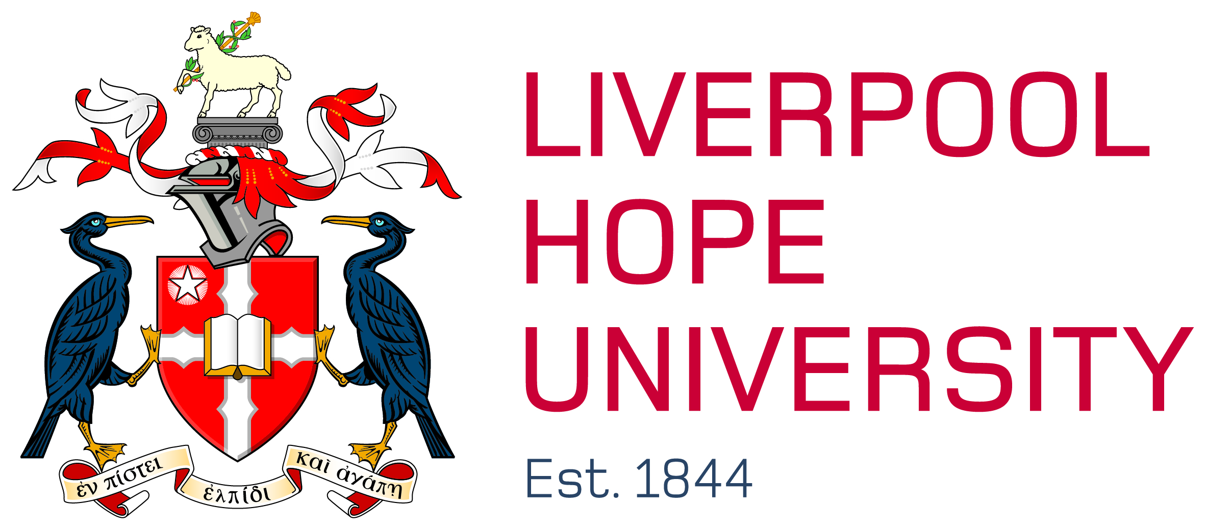
Christ’s, Notre Dame, S. Katharine’s and LIHE Grand Reunion: 6th - 8th July 2018 Booking Form
Attendee details
Title_____________ Name ____________________________________________________________________
Maiden Name (if applicable)______________________________ Leaving Year___________________________
Address____________________________________________________________________________________
_________________________________ Post Code_________________________________________________
Tel. No_____________________________________________________________________________________
Email_______________________________________________________________________________________
Dietary/access requirements____________________________________________________________________
For purposes of the dinner and accommodation, who would you like to be grouped with (where possible) _____ ____________________________________________________________________________________________
Please tick if you do not want your name to be used for event information (E.g. list of attendees)
Please tick if you do not want your details to be kept on the alumni mailing list.
N.B. If you are booking for additional guests, please let us know their details overleaf/by email.

Payment
There are two ways to pay:
Cheque (made payable to Liverpool Hope University) or via the Online Store at: store.hope.ac.uk
Please return to: Clare Baker, Alumni Office, Liverpool Hope University, Hope Park, Liverpool, L16 9JD
Tel: 0151 291 3219/Email: alumni@hope.ac.uk. We will confirm your booking within 10 working days. Please contact us if you do not receive a letter in due course. Refunds cannot be given for cancellation less than 14 days prior to event.

Please return to: Clare Baker, Alumni Office, Liverpool Hope University, Hope Park, Liverpool, L16 9JD

